# Collection Soft Link – Detailed Design

This document provides impact analysis of the DME functionalities needed to be updated in order to support a soft linked collection.

## DME Features – specific handling / logic for linked collection

The following DME features will need to be modified to be aware of a linked collection and implement specific logic –

1. Delete collection – delete the collection itself but don’t delete ‘collection listing entries’. Error if requested to do so
2. Migrate collection – don’t allow – deny the request
3. Download collection – download the ‘collection listing entries’ of the linked collection
4. Tier collection – don’t allow – deny the request
5. Browse collection – show the ‘collection listing entries’ of the linked collection

## Detailed Impact Analysis

### Get Collection Services in HpcDataManagementService

We have 4 flavors of ‘get collection’ services. In all of them the service returns data about the collection itself and data about ‘collection listing entries’ (sub collections and data objects under this collection).

These 4 services will need to be updated to account for a soft link collection, in which the data about the ‘collection listing entries’ needs to be obtained from the linked collection.

The 4 services are

/**

* Get collection by its path.

*

* **@param** path The collection's path.

* **@param** list An indicator to list sub-collections and data-objects.

* **@return** A collection.

* **@throws** HpcException on service failure.

*/

**public** HpcCollection getCollection(String path, **boolean** list) **throws** HpcException;

/**

* Get collection by its path and all sub-collection and data objects list

*

* **@param** path The collection's path.

* **@return** A collection.

* **@throws** HpcException on service failure.

*/

**public** HpcCollection getFullCollection(String path) **throws** HpcException;

/**

* Get collection children by its path. No collection metadata is returned.

*

* **@param** path The collection's path.

* **@return** A collection.

* **@throws** HpcException on service failure.

*/

**public** HpcCollection getCollectionChildren(String path) **throws** HpcException;

/**

* Get collection children by its path starting at user specified offset.

*

* **@param** path The collection's path.

* **@param** offset The offset to start.

* **@return** A collection.

* **@throws** HpcException on service failure.

*/

**public** HpcCollection getCollectionChildrenWithPaging(String path, Integer offset) **throws** HpcException;

These 4 services will need to be update to account for a soft link collection, in which the data about the ‘collection listing entries’ needs to be obtained from the linked collection.

### Get Collection Services Usage Summary

All the DME code that is using the 4 methods above will need to update and incorporate logic for linked collections as needed.

Note that some usage of these services is to simply validate if a collection exist. We can use this opportunity to do a small refactor and create a separate method to detect collection existence, so the code is not impacted by linked collection.

#### getCollection()

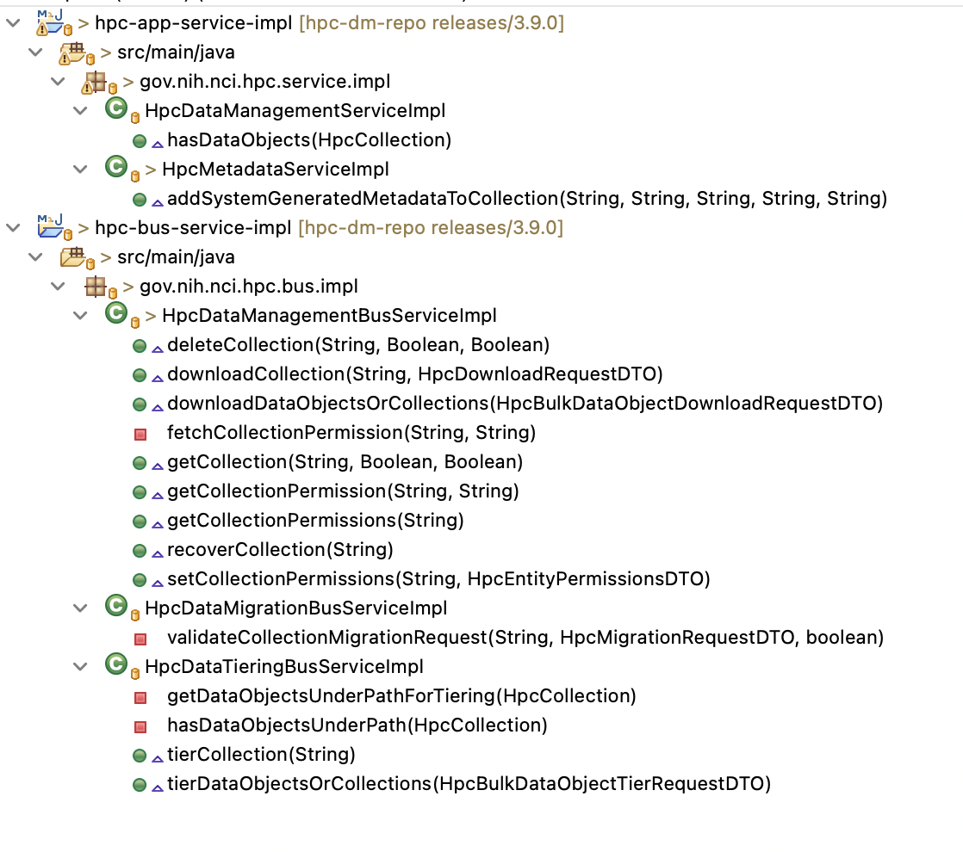

#### getFullCollection()

#### getCollectionChildren()

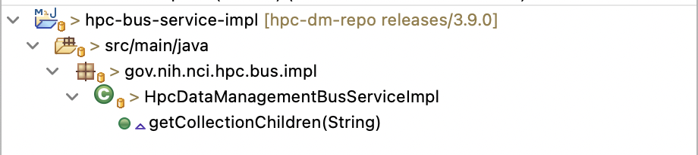

#### getCollectionChildrenWithPaging()

